PoD machine walkthrough

First, perform a port scan with nmap.

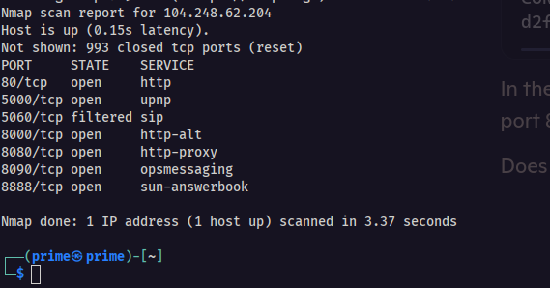

If you perform a directory scan, you can only see this file.

Sensitive Data Exposure

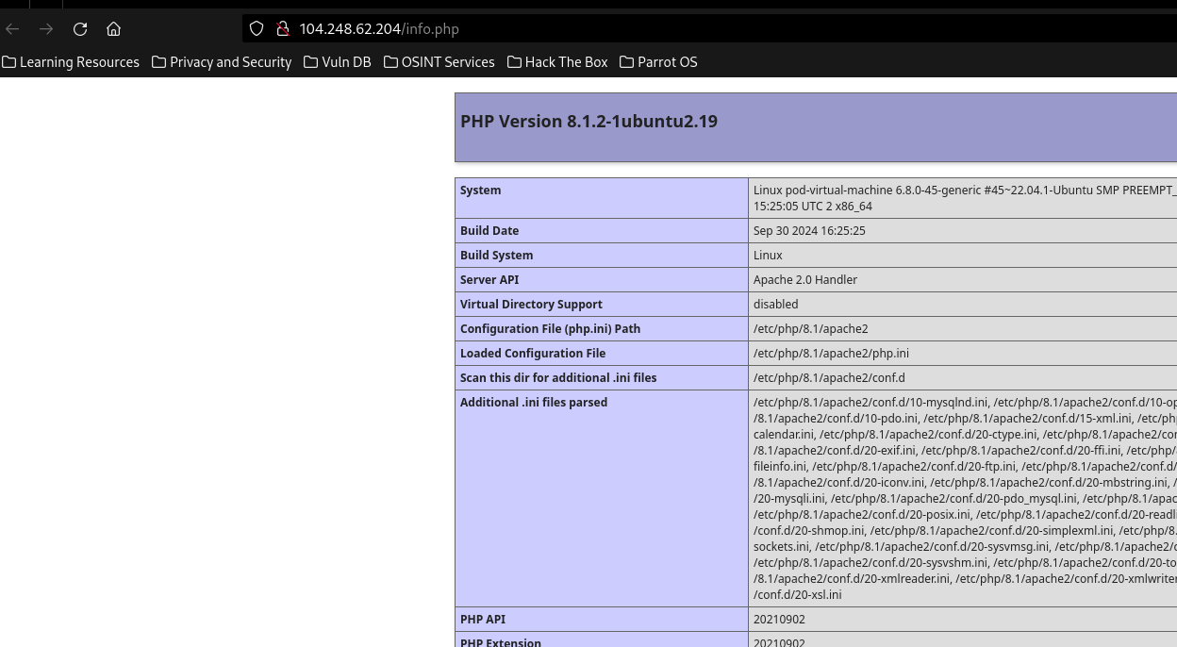

As you see, we have 7 open ports. 80 is a normal Apache2 server. Except for the 5000th port, we cannot see anything. In 5000 port, we see this

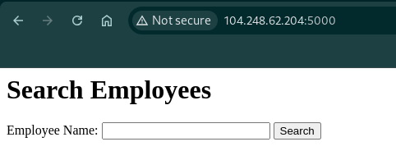

This is a searching site and it sends data with the GET method.

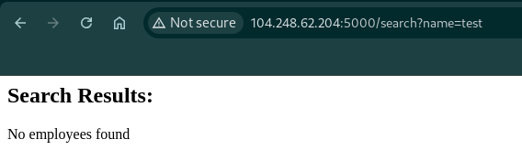

Here I made a scan with the sqlmap tool.

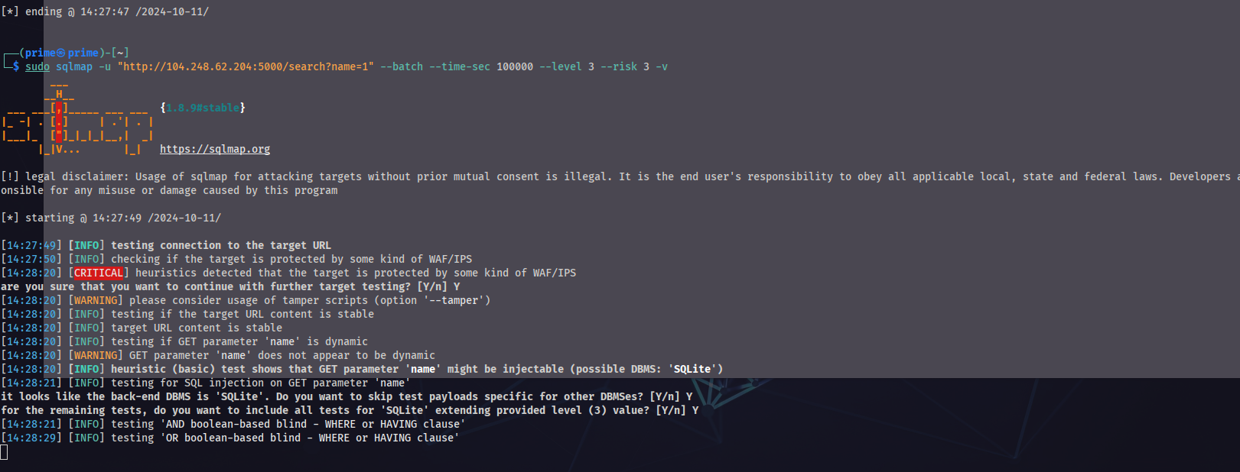

And we find a SQLi in this path

We dumped the database and found this text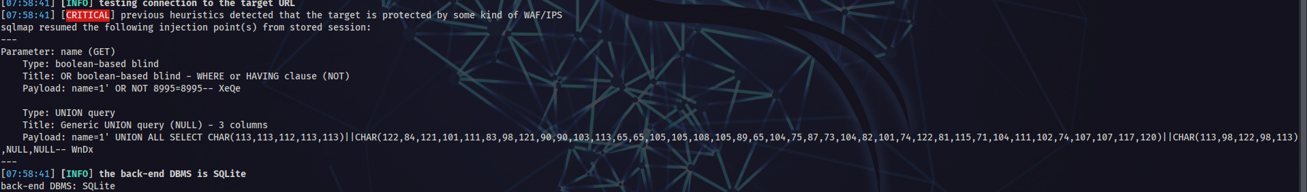

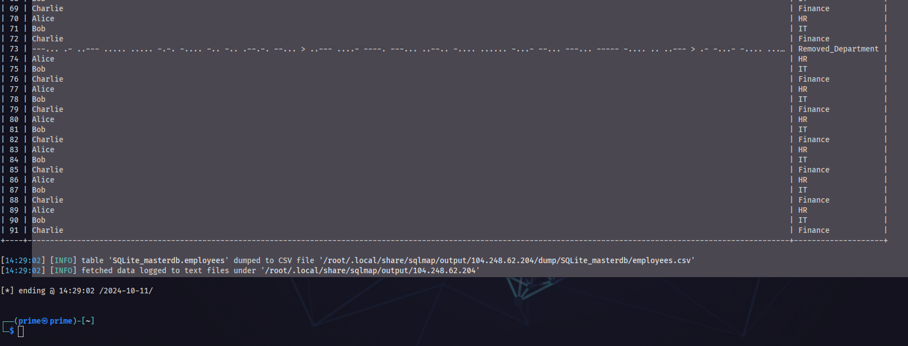

---... .- ..--- ..... ..... -.-. -.... -.. -.. .--.-. --... > ..--- ....- ----. ---... ..--.. -.... ...... -...- --... ---... ----- -.... .. ..--- > .- -...- -.... ...…

Converted this to normal text 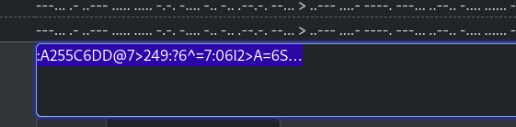

And decoded one time again.

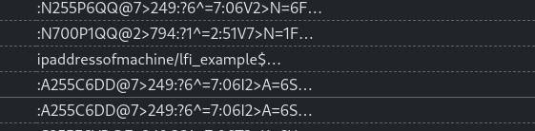

This is our 2nd web vulnerability’s path. When we go to the

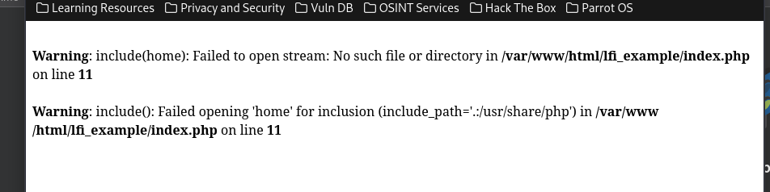

If you analyze error, you can see that index.php tries to include some php page. This means we can also do it.

http://<IP>/lfi_example/index.php?page=../../../../../../etc/passwd

This is our payload and result is

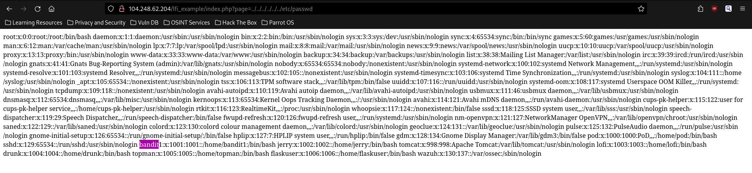

We found the user and we connected with bandit1:bandit1 username and password via SSH.

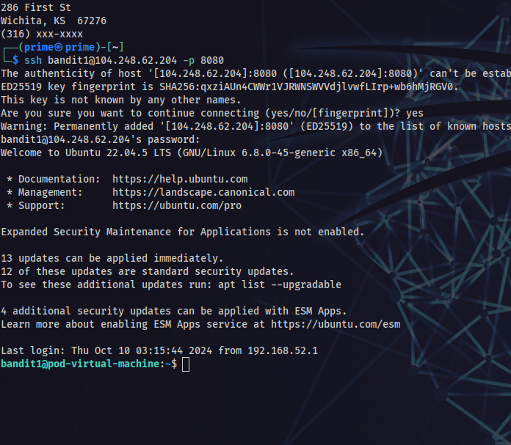

Open the .profile file and you will see the line that does not belong there.

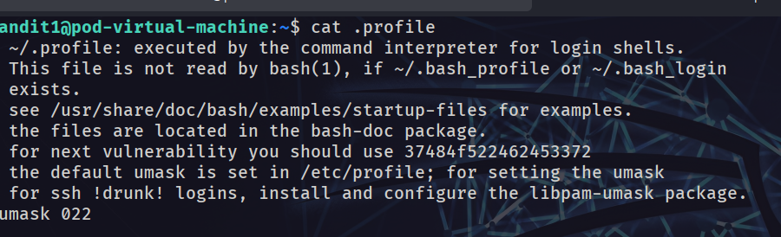

Decode it

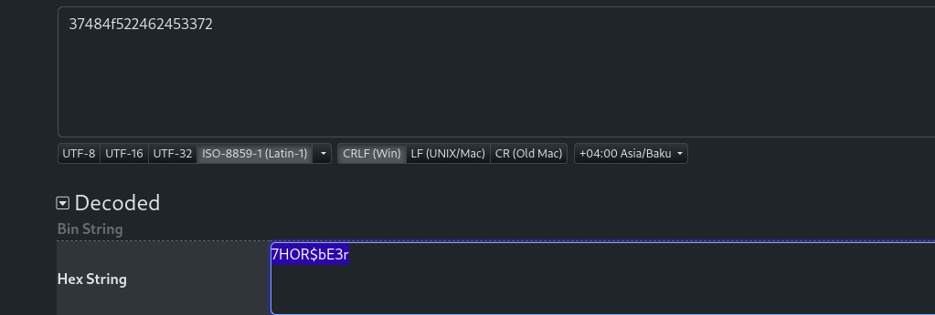

This is the password of “drunk” user.

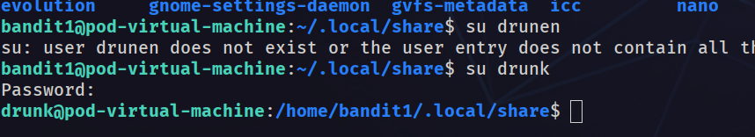  
In “drunk” home directory, you can see Friends.jpg. We can download the image with “scp” command.



In here, used our server for getting image from server. Then I uploaded it to [this site](https://stylesuxx.github.io/steganography/) and result is..

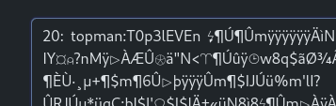

We have the password of the topman user. In topman, if you look at the history. you will see the password of root user.

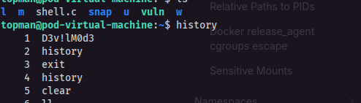

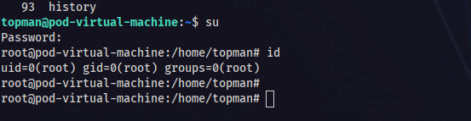

And this is end of walkthrough